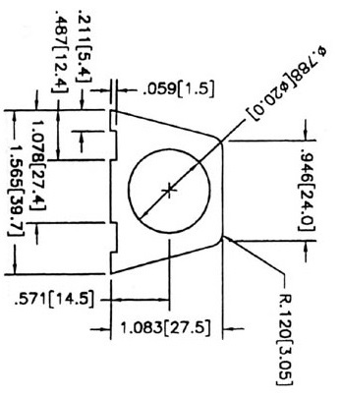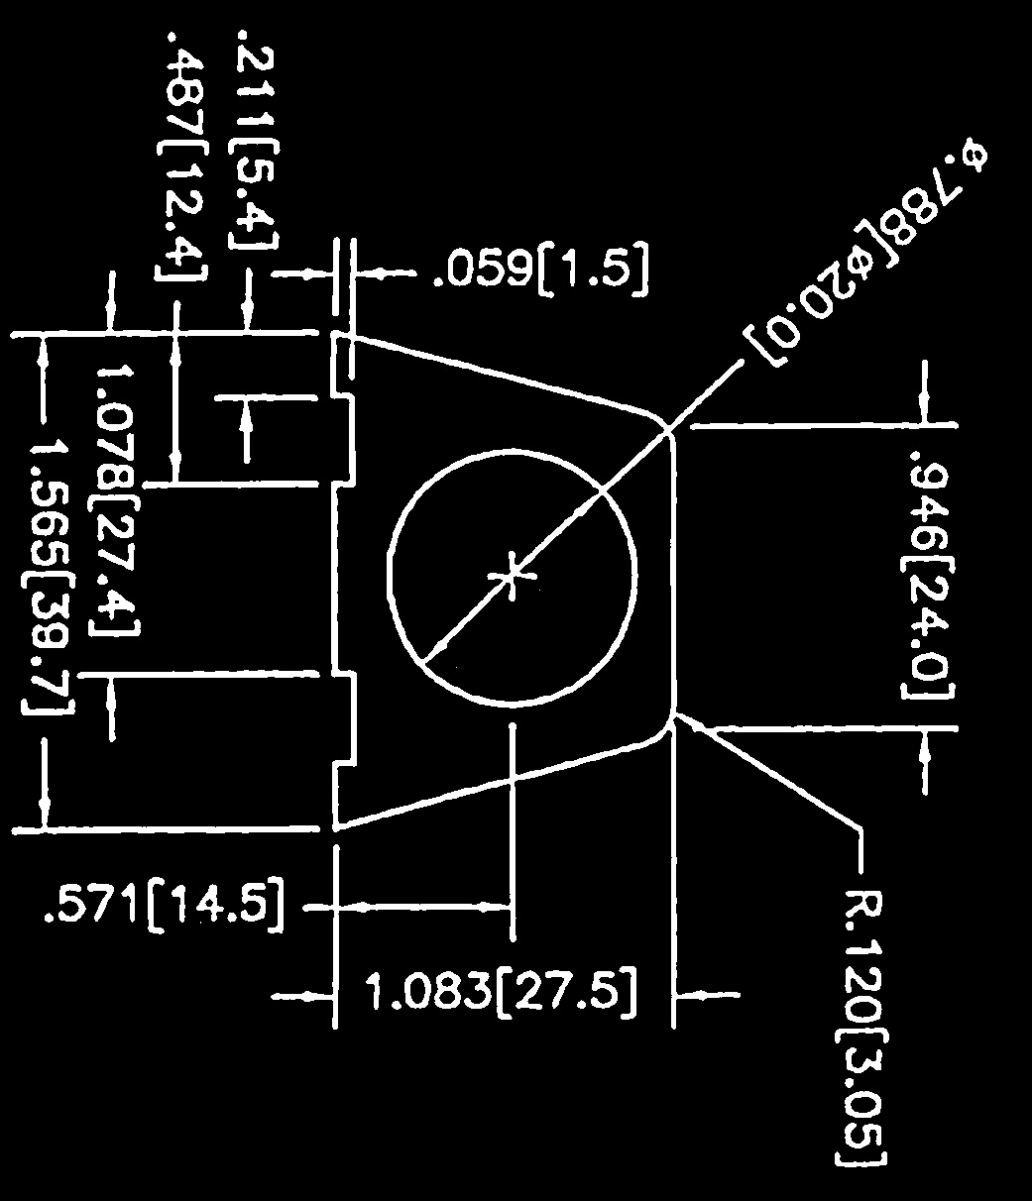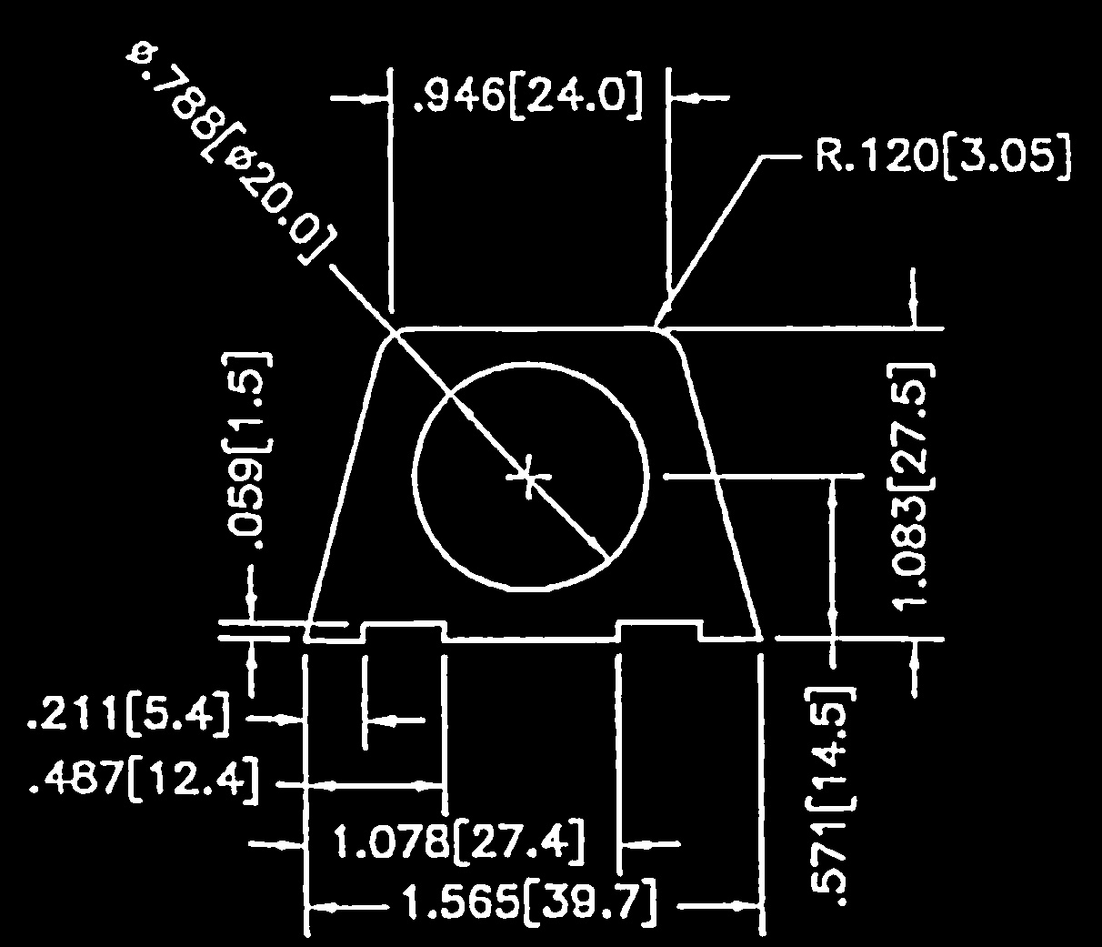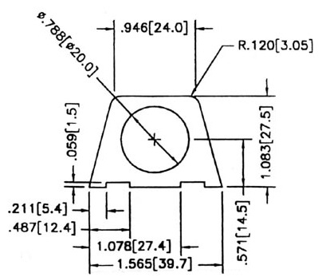

Threshold filter is applied on the image

Contours matching characters are determined and (to be done) angled lines are determined

Start

Possible character sets are characterized by determining position of center of each contour and contour extremes and not by bounding boxes

D

Perform OCR on horizontal character sets

C

Input Image

A

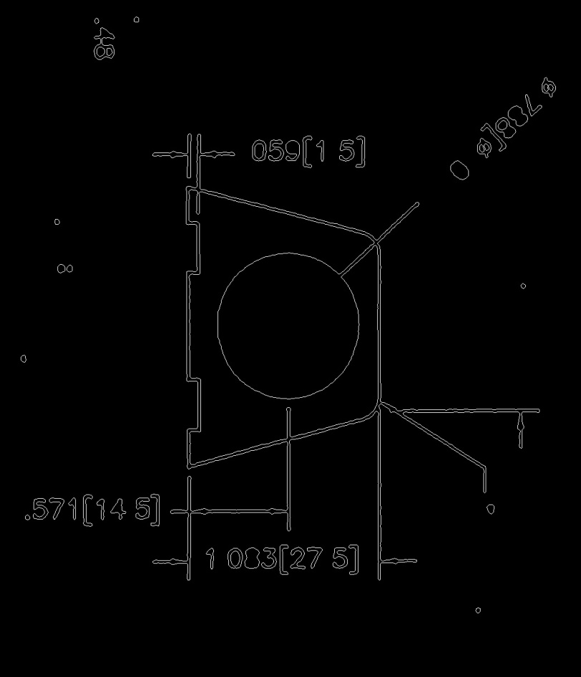

A

B

D

C

For all the matches, rotate the threshold image and repeat the process from determining possible character sets to OCR

Compare the angular orientations of the character contours and the angled lines in the drawing

B

B

If all the contours nearly resembling characters are horizontal

Separate the possible character sets

Yes

Rotate input image clockwise 90 degrees and repeat steps from threshold filter being applied on image till OCR

No

Yes

Separate the possible character sets

If all the contours nearly resembling characters are horizontal

*After rotation, sometimes the image may be 180 deg rotated, we must check for that too*

B

Get the points that are the extremes of the character sets

Draw lines that will be bounding boxes for the characters sets however they are oriented (horizontal, vertical or angled)

The strings and the image with bounding lines around the character sets are the outputs.

End